FreeMind
Version 0.7.0

Windows Installation Guide

Project : FreeMind
Date Published : 23rd December, 2003
Authors: Andrew Iggleden & Robert J. Alexander

Table of Contents
1. System Requirements 1
1.1 Operating System 1
1.2 Required Software 1
2. Download the Software 2
2.1 Java 2
2.2 FreeMind 4
3. Install the Software 5
3.1 Java 5
3.2 FreeMind 8

System Requirements

Operating System
Microsoft Windows 95
Microsoft Windows 98SE
Microsoft Windows 2000
Microsoft Windows ME
Microsoft Windows NT
Microsoft Windows XP

Required Software
Java 1.4 or greater.
To see if you have the right version installed
- Select Run from the Start Menu
- Type in command and press <ENTER>
- Type in java –version and press <ENTER>

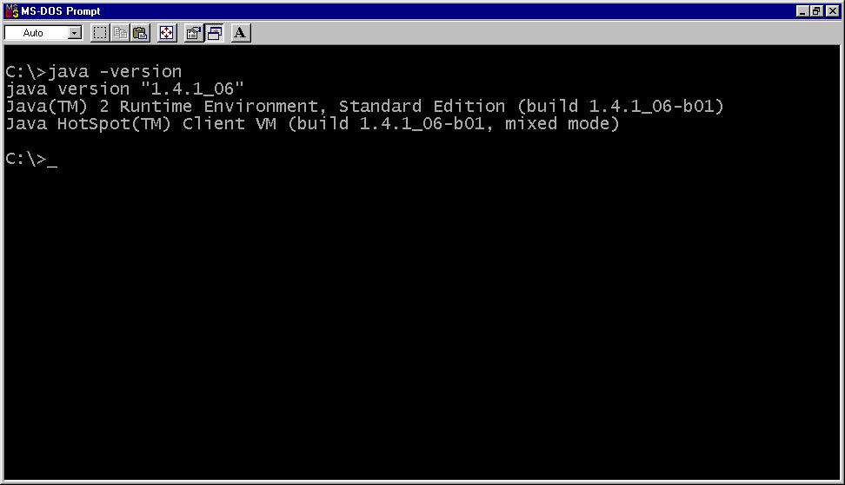

Download the Software

Java
If you don’t have a correct version of Java then please follow the steps below.
- Download the latest version of the Java Runtime Environment (JRE) from http://java.sun.com/j2se/1.4.2/download.html
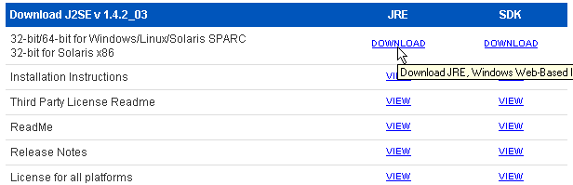
- Look for the section “Download J2SE v1.4.2_03” and click on the JRE Download link for the 32 bit/64 bit for Windows …..

Read the licence agreement, if you agree click on “Agree” and click “continue. If you do not agree then FreeMind cannot be installed.
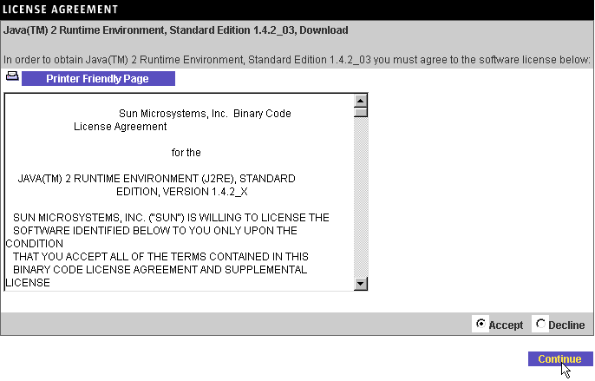

Click on Windows Offline Installation, Multi Language

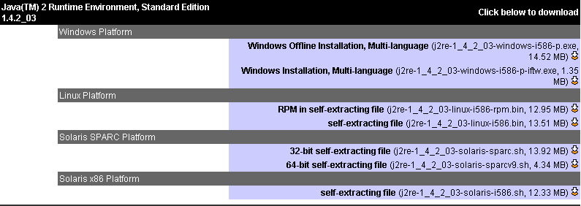
You will be prompted to either Run the program or save it to disk.
Select Save this program to disk and click OK.
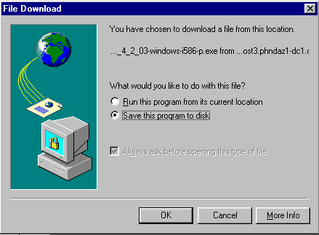

You will be asked for the location to save the file to. Select the folder you want to save the file to and click Save.
The file will now be downloaded and saved to the selected folder.

FreeMind

- Download the latest version of FreeMind from http://freemind.sourceforge.net/
- Click on the “download binaries” link in the Download paragraph as shown in the picture below:

- You will be presented a list of download sites from which you can download your installation program from.

- Choose the one which you think might be faster for you (sometimes it is the nearest to you geographically).

- Remember where you save the resulting file which at the time of this writing will be named freemind-windows-installer-0_7_0.exe

Install the Software

Java
Double click on the downloaded JRE file and you will see the following screens.
The best way is to simply choose all defaults.
Please note your screens could look a little different.
Read the licence agreement, if you agree then click on “I accept the terms in the licence agreement”.
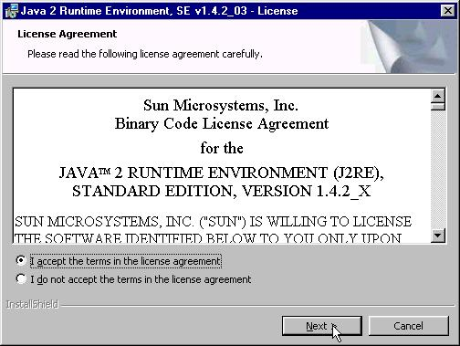
Click Next

Click Typical then click Next.
Note : Only Advanced users should select Custom.
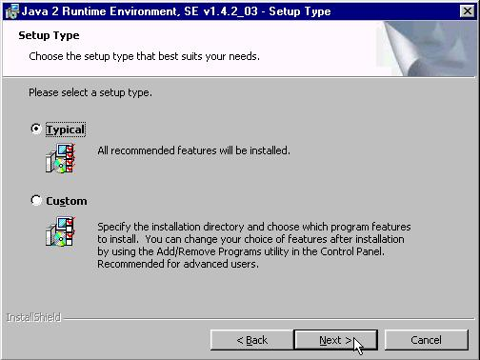
The following screen shows Java being installed.
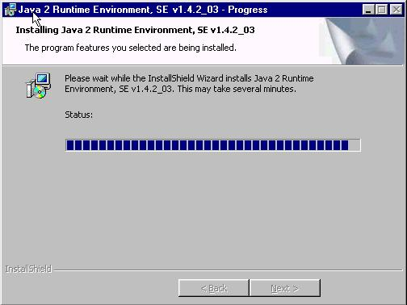

The Java Runtime Environment (JRE) has now been installed. If you would like to compile FreeMind then please install the Software Development Kit (SDK) etc.
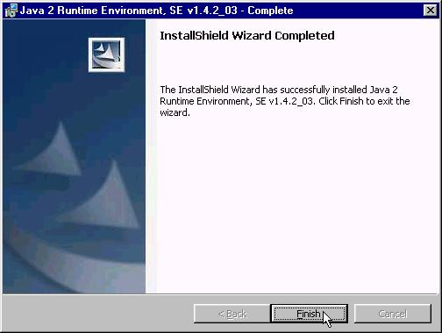
If you do require more information on this, then I recommend the “Quick guide to setting up Freemind on an XP system” by Robert J. Alexander.

FreeMind
Double click on the downloaded JRE file and you will see the following screens.
The best way to install FreeMind is to simply choose the defaults.
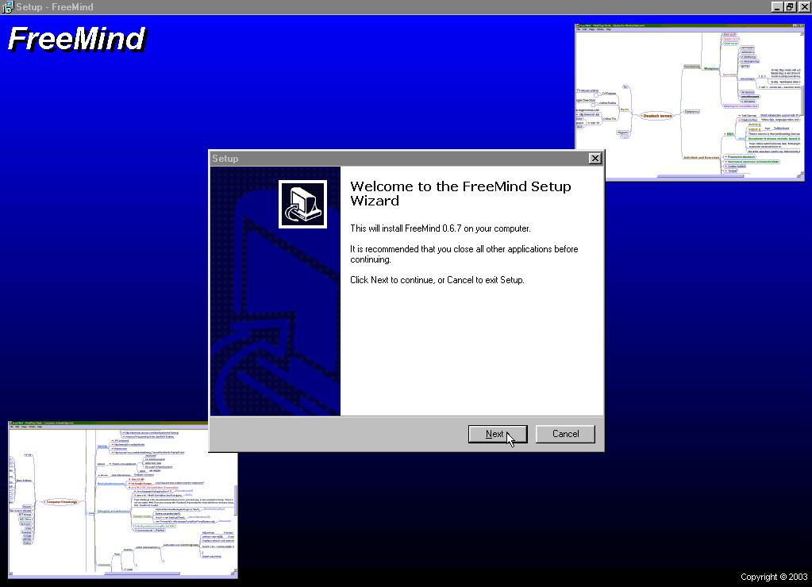
Click Next

Read the licence agreement, if you agree then click on “I accept the terms in the licence agreement”.
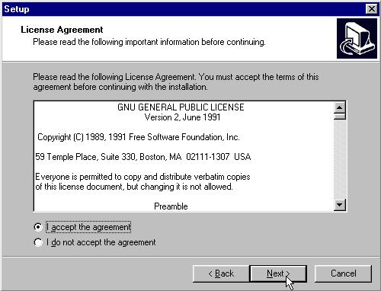
Click Next

If you haven’t installed Java then now is the time to stop installing FreeMind and install Java.
Click Next
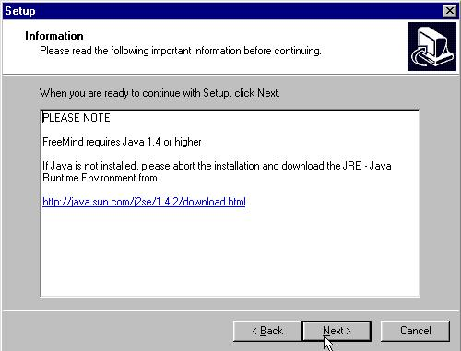
Select the directory you want to install FreeMind into. Once again leave the default and click Next
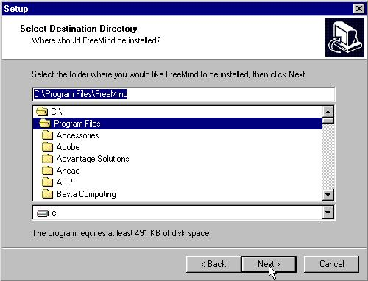

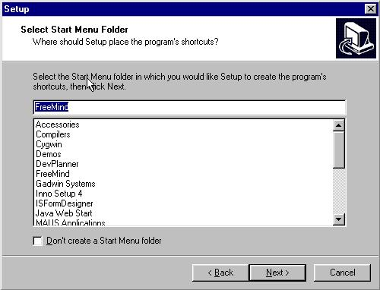
Select the Start Menu Folder and Click Next.

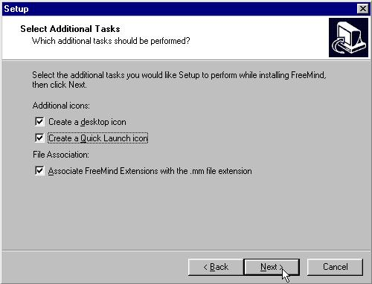
Select which tasks you want to have done during installation. It is highly recommended that you Associate FreeMind Extensions with .mm.
Click Next

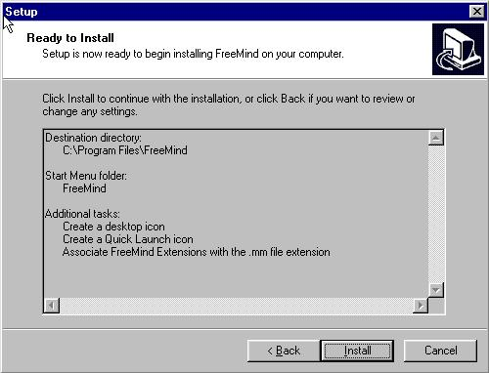
This screen informs you of what the installation process will do.
Click Install

This screen is a short message about the Authors and Contributors of FreeMind.
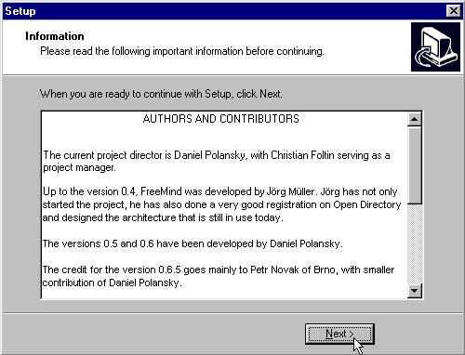
Click Next

The Java Runtime Environment (JRE) has now been installed. If you would like to compile FreeMind, then please install the Software Development Kit (SDK) etc.
If you do require more information on this, then I recommend the “Quick guide to setting up Freemind on an XP system” by Robert J. Alexander."

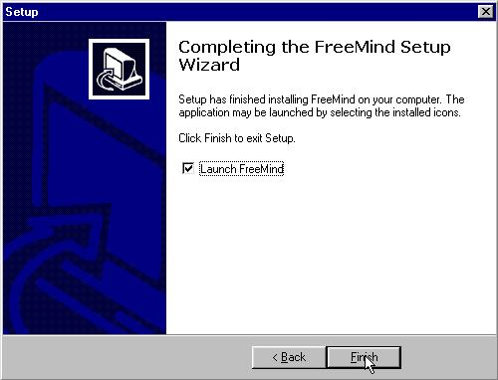

Acknowledgements

Java is a trademark of Sun Microsystems Inc.
Windows is a trademark of Microsoft.

